**Define:**

Dereference pointer?

A tool that accesses what is stored in a memory location.

How are arrays similar to pointers?

An array is a collection of pointers.

**LAB ASSIGNMENT**

Task 1:

Create an Array that holds a 20 random integers between 1-50.

Create an iterator that will return the memory address and value for each integer present in the Array.

(Place snipping photo below.)

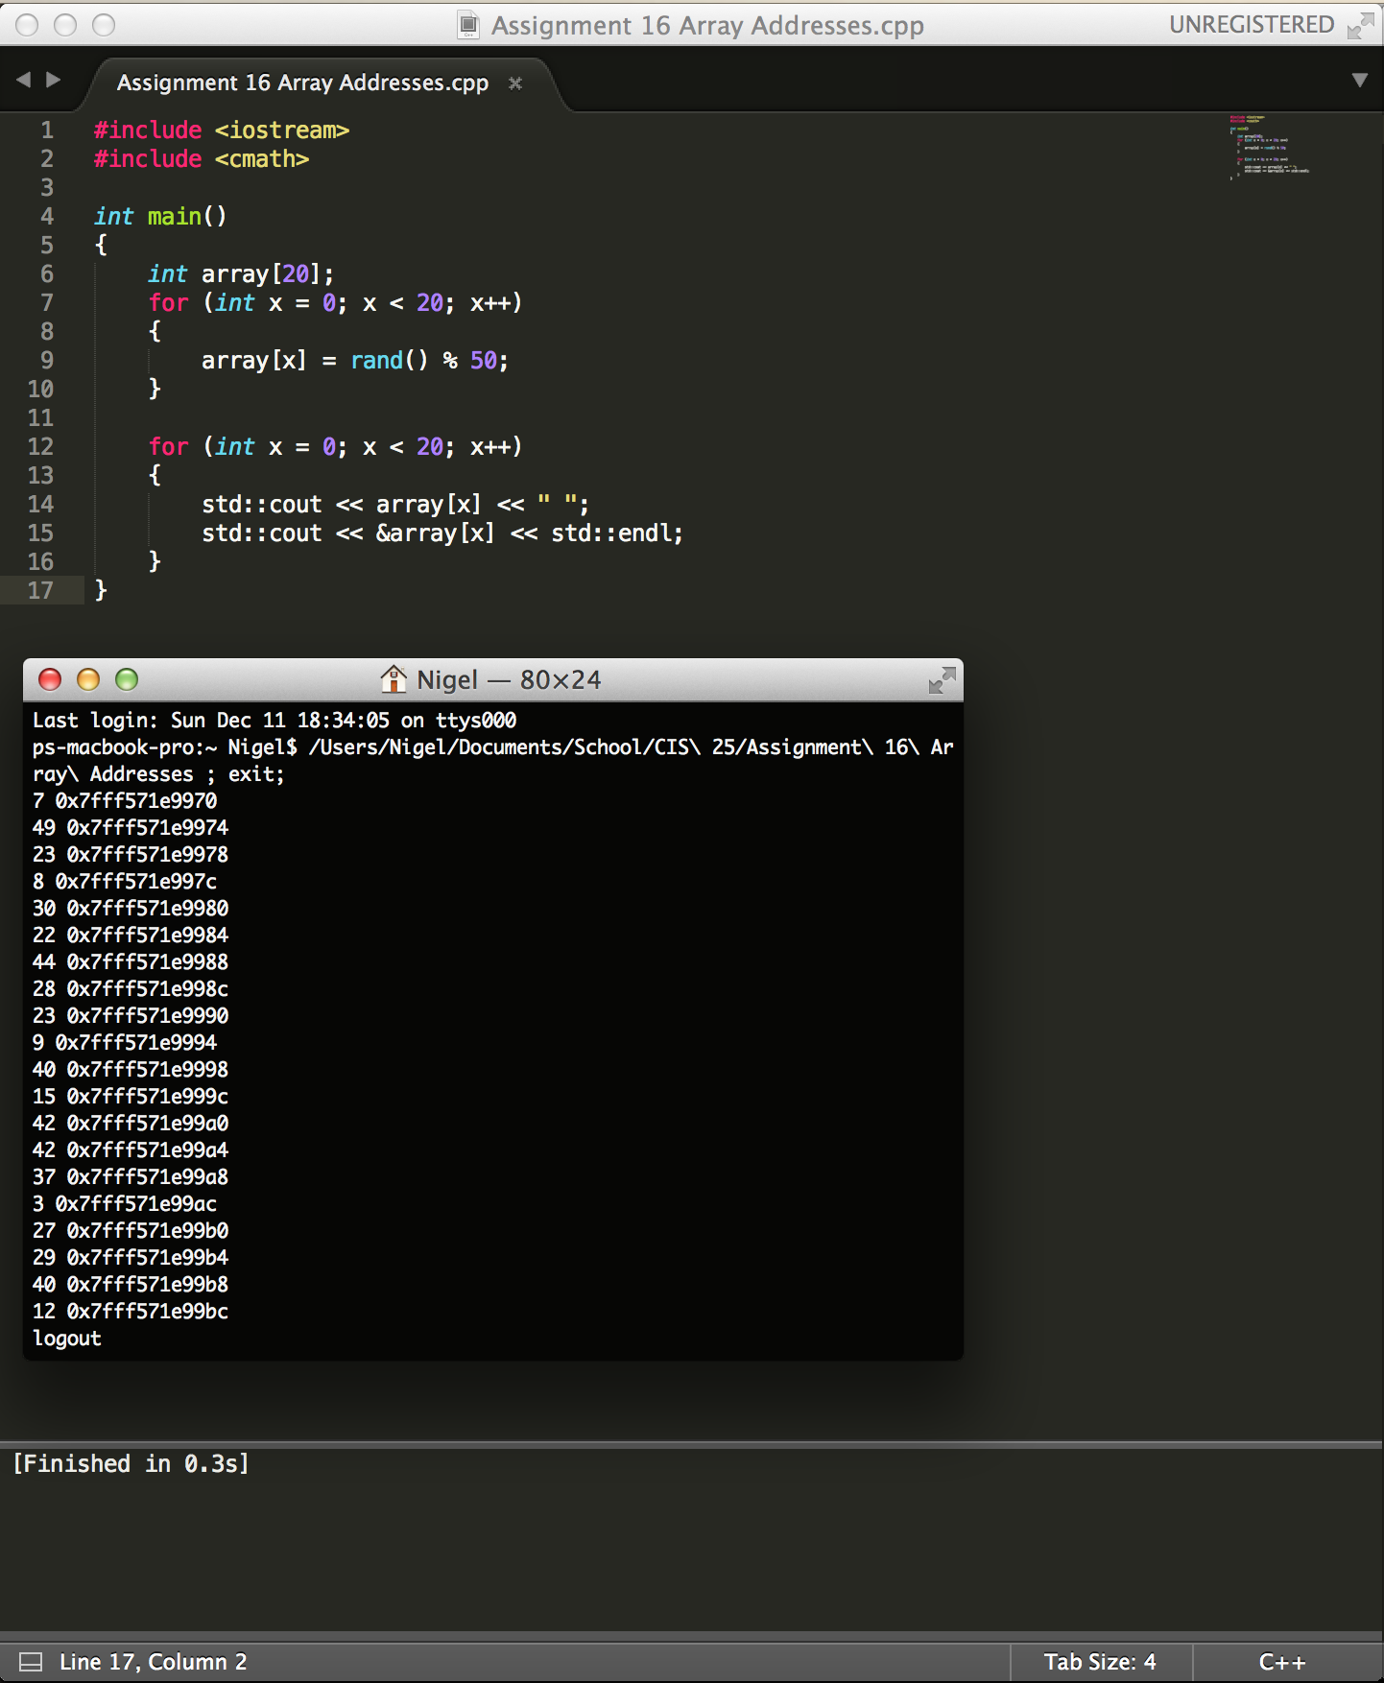

Task 2:

Write a function called accelerate() that will receive an input from main() input the speed of a vehicle, and an amount to accelerate the vehicle. The function adds the amount to the speed to accelerate the vehicle. The speed parameter should be passed by reference, and amount by value.

Output original speed and final speed.

(Place snipping photo below.)